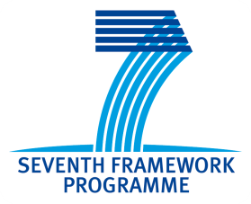

Research Opportunities Workshop
South Balkan and Mediterranean
23rd of September 2011, Bucharest, Romania
AGIR Hall, Calea Victoriei 118
Workshop Programme
Timeframe | Topic | Speaker
08.30 – 9.00 | Registration
9.00 – 09.10 | Opening Speech | Dan Caraman - InteCo  Mark Robinson - UNEW
9.10 - 9.30 | Romanian research in EU context | Prof. PhD Dragos Ciuparu  Secretary of State  President of the National Authority for Scientific Research
9.30 – 09.45 | The aim of the TransNEW project and the workshop’s goals | Sian Evans - UNEW
09.45 – 10.10 | 7/ 8th Framework Program – priorities of the transport field, development trends, opportunities, CE expectations | (TBC) Elena Mihaela Williams - EC
10.10 - 10.35 | Transport research opportunities according to the EU and national research policies | Beatrice Paduroiu  ANCS
10.35 – 10.50 | Coffee break and Networking
10.50 – 11.10 | FP7/ FP8 consortium skills and opportunities for transport researchers: Transport NCP alliance | Sabrina Bozzoli  ETNA
11.10 – 11.30 | TransNEW database | ICI Representative
11.30 – 11.50 | Successful EU Project Management - Do’s and Don’ts, best practice, effective advice | Mark Robinson - UNEW
11.50 – 12.20 | Cooperation opportunities in the region (why cooperate with partners in the region?, advantages, transport modes and themes) | Gurcan Ozan - TUBITAK
12.20 - 13.30 | Lunch and Networking
13.30 – 14.00 | Good practice examples Successful transport research projects | Prominent project managers
14.00-15.00 | Open debate, project proposal presentations | Researchers interested in promoting their project ideas
15.00 | Closing Speech | Mark Robinson - UNEW
 | End of the event

