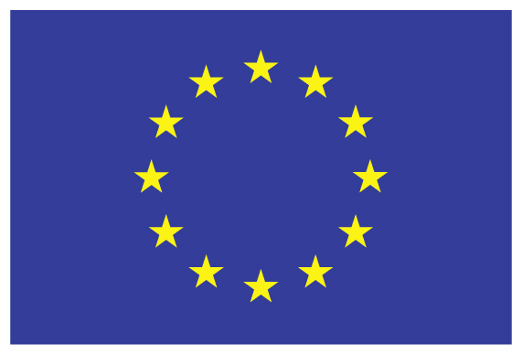 | 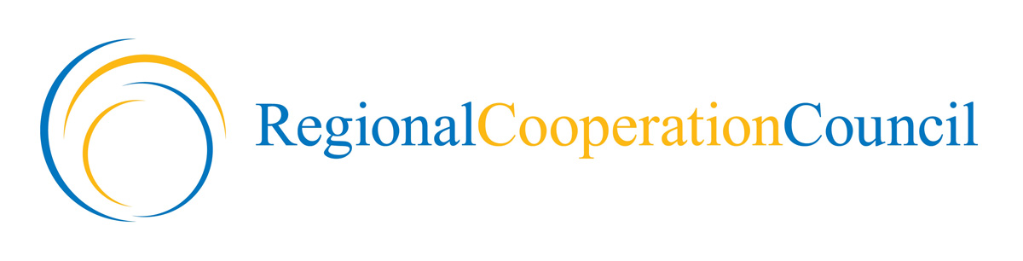 | 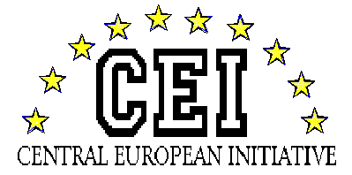

Improving Cooperation in South-East Europe
by Actions for Strengthening the Regional Cooperation Council”

IPA Regional Programme 2010 - EuropeAid/131229/C/ACT/Multi

Kick-off meeting

March 16th, 2012 – Sarajevo (BiH)
Hotel Holiday Inn - Zmaja od Bosne 4

First Session

09.00 Registration

09.30 Welcome addresses
RCC and CEI partnership and current operations in the frame of SEE regional initiatives
Mrs Jelica Minic, RCC Deputy Secretary General // Mr. Giorgio Rosso Cicogna, CEI Alternate Secretary

10.00 Break/Press opportunity

10.10 Project rationale and presentation of activities
Mr. Ugo Poli, CEI Project Manager

10.40 The regional dimension of SEE and the objectives of the IPA regulation reform
Mr. Yngve Engstroem, Head of Unit Regional Cooperation and Programmes,
DG Enlargement

11.00 Questions & Answers

11.10 Coffee break

Second Session

11.40 Evolution of trade and economic situation in the framework of CEFTA agreement
Mrs Renata Vitez – Director CEFTA Secretariat

12.00 Bridging experience of European Territorial Cooperation in SEE with the IPA programming
Ivan Curzolo, SEE Operational Programme, Acting Head of the Joint Technical Secretariat

12.20 WBC INCO-NET experience for supporting RTD and innovation in the region
Mrs Elke Dall, Project Coordinator / to be confirmed

12.40 EBRD current operations and coordination with other IFIs in the SEE region
Mr. Libor Krkoska, EBRD Senior Banker, Head of Office Sarajevo (Bosnia & Herzegovina)
/ to be confirmed)

13.00 Prospects of EU enlargement until 2020
and the growth potential of the Adriatic – Danube - Black Sea region
Lothar Jaschke, European External Action Service - Western Balkans Division
Policy Officer Serbia, Montenegro, Croatia, Regional Cooperation

13.20 Questions & Answers

13.30 Final remarks from the RCC and CEI secretariats
Mrs Jelica Minic, RCC Deputy Secretary General // Mr. Giorgio Rosso Cicogna, CEI Alternate Secretary

14.00 End of the Kick-Off Meeting & Buffet Lunch

Rationale of the Kick-Off meeting
(based on the project form - WP 5.1)

The Kick-Off Meeting aims to launch the action in front of a large audience of CEI and RCC partner organization and regional stakeholders. Having ten Member States in common CEI and RCC are also involving their representatives at the level of respective National Coordinators (Ministries of Foreign Affairs).

The occasion of the Kick-Off Meeting will facilitate the relationship and synergy of the project with pivotal actors playing a role in Western Balkans’ regional cooperation, from the level of European institutions to that of implementing bodies of more relevant regional programmes.

The event is for sharing updated information on what is going on in the SEE region and for the opportunity of a concrete and operational comparison of high level standpoints on current topics and on expected multiplication of the project impact.

