Press release | October 2023

The Engine for South European Deep Tech launches the second Open Call for the S3E Program

In its mission to accelerate entrepreneurship and innovation in Southern Europe, the EU-funded project S3E brings the ultimate program of support for researchers, startups and corporates developing Deep Tech solutions with social and sustainable impact at their core.

The Southern European Entrepreneurship Engine consortium is pleased to announce the launch of its second Open Call for the S3E program — the EU-funded initiative fostering Deep Tech entrepreneurship in South European countries.

Having supported over 40 innovators and entrepreneurs during the first iteration of the program, S3E is coming back with a second edition to continue offering new opportunities to the deep tech ecosystem looking to bridge the go-to-market gap in Southern Europe.

‘’I totally recommend the S3E program to anyone who wants to turn their ideas into successful businesses. The program's effectiveness and the support we received were incredible, and it has given us the confidence to pursue our entrepreneurial dreams.’’

Alexandra Kortsinoglou, TriPHYTE Researcher
S3E Start, 2023 Cohort

What is the S3E Program and who is it for?
The S3E Accelerator Program is built around 3 tracks of bespoke services, tailored to the needs of different groups operating within the deep tech innovation ecosystem.
- S3E Start: helps research teams and tech transfer offices to explore the commercial viability of their deep tech projects. Through an 18-week online training program, the selected research teams will learn first-hand about the processes required to develop a business case for science-based products or services. The teams will be paired with a mentor who will give them 1-1 support and mentorship and will also have the opportunity to pitch in front of investors at the end of the program.
- S3E Charge: supports deep tech startups in their growth phase that want to improve their business model and learn how to access dilutive and non-dilutive funding. Over 14 weeks, the selected startups will receive tailored mentorship to guide them through the validation process of their product or service, and the creation of an investment-ready business plan. This track also includes networking with leaders in entrepreneurship and innovation and the opportunity to pitch in front of investors at the end of the program.

- S3E Reverse: connects corporate challenges with solutions developed by scaleups and SMEs thanks to our Brokerage Program, based on a successful open innovation methodology. To access this track, large companies and public organisations have to submit a deep tech challenge, acting as the ‘Challengers’; in the second stage, scaleups and SMEs are invited to respond to the selected challenges with their innovative deep tech solutions or products, becoming the ‘Solvers’. Participants from both sides will engage in a Brokerage program and receive expert support for business collaboration.

How to apply
The S3E Open Call #2 welcomes applications from the following countries:
- South European countries: Bulgaria, Croatia, Cyprus, Greece, Italy, Malta, Portugal, Romania, Slovenia and Spain.
- Associated countries: Albania, Bosnia and Herzegovina, Montenegro, North Macedonia, Serbia, Kosovo and Turkey.
Those interested in joining the S3E Program can access the relevant application form and guiding materials available on the S3E website.

Timeline for S3E Open Call #2
- 15 December 2023: Deadline to apply to S3E Charge (startups) and S3E Reverse (large organisations acting as ‘Challengers’)
- 12 January 2024: Deadline for apply to S3E Start (research teams & tech transfer offices)
After receiving the applications and running an independent evaluation, the selected participants will be invited to join their respective track as part of the S3E Accelerator Program:
- S3E Start will be active from 6 February until 6 June 2024
- S3E Charge will run from 18 January until 26 April 2024
- S3E Reverse will develop its Brokerage Program between April and September 2024 (the Open Call for Solvers will launch on 15 January 2024)

More information about the project and the open call is available on the S3E website.
About South3E:

South3E (also known as S3E) is an ambitious joint initiative launched in September 2022, funded by the European Commission as part of the Horizon Europe Programme. During its 30-month run, 4 partners from Portugal, Greece, Ireland and Spain have joined forces to make S3E a reality. The team includes experts from the research, innovation and acceleration ecosystem, together with policy and community building experts.

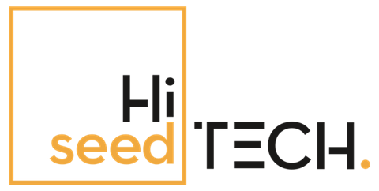 |  |  | 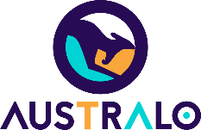

Disclaimer: Funded by the European Union. Views and opinions expressed are however those of the author(s) only and do not necessarily reflect those of the European Union. Neither the European Union nor the granting authority can be held responsible for them.

