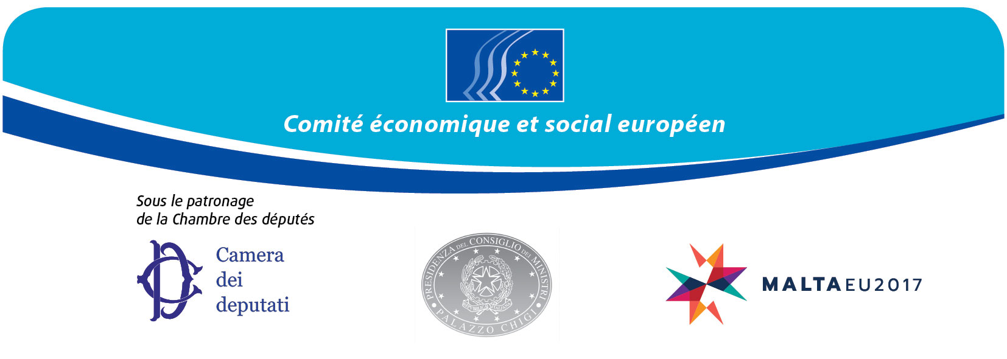
EN

Sixty years of European community – let’s shape the future!

Rome, 13 March 2017

Auletta dei Gruppi Parlamentari
Complesso di Montecitorio - Via del Campo Marzio, 74

Programme

8.15 – 9 a.m. Reception - coffee

9 – 10 a.m. Opening statements

- Laura Boldrini, president of the Chamber of Deputies
- Georges Dassis, president of the European Economic and Social Committee
- Paolo Gentiloni, president of the Italian Council of Ministers
- Antonio Tajani, president of the European Parliament (to be confirmed)
- Ian Borg, parliamentary secretary of the Maltese Presidency

10 - 11.30 a.m. Social Europe as a tool for tackling inequalities
Coordinator: Gabrielle Bischoff, president of Group II (Employees)

- Maria Joao Rodrigues, EP rapporteur on the social pillar, former Portuguese minister for labour
  - Allan Päll, secretary-general, European Youth Forum
  - Maurizio Gardini, president, Alleanza delle Cooperative Italiane
  - Valeria Ronzitti, secretary-general of the European Centre of Employers and Enterprises providing Public Services
– Susanna Camusso, general secretary of the Italian General Confederation of Labour (CGIL)

Debate
Coordinator’s conclusions

11.30 a.m. – 1 p.m. Completing the Economic and Monetary Union for a stronger Europe
Coordinator: Jacek Krawczyk, president of Group I (Employers)

- Euclides Tsakalotos, Greek Minister for Economic Affairs and Finance (to be confirmed)
- James Watson, Director of Economics, BusinessEurope
- Luca Visentini, secretary-general of the European Trade Union Confederation
- Giovanni Sabatini, Chairman of the Executive Committee of the European Banking Federation
- Véronique Willems, secretary-general of the European Association of Craft and Small and Medium-Sized Enterprises (UEAPME)

Debate
Coordinator’s conclusions

1.15 – 3 p.m. Lunch

3 - 4.30 p.m. Integration policies and immigration
Coordinator: Luca Jahier, president of Group III (Various Interests)

- Dimitris Avramopoulos, European Commissioner (to be confirmed)
- Domenico Minniti, Italian Minister for Home Affairs
- Filippo Grandi, United Nations High Commissioner for Refugees
- Prof. Marco Impagliazzo - president of the Comunità di Sant’Egidio - The pioneering experiment on humanitarian corridors
- Oonagh Aitken, Solidar Association International

Debate
Coordinator’s conclusions

4.30 - 5 p.m. Tribute to Dr Pietro Bartolo, head of healthcare, island of Lampedusa

5 – 5.20 p.m. Conclusions

- Sandro Gozi, Italian deputy state secretary for European policy and affairs
- Georges Dassis

_____________

Languages:
Active - English, French, Italian and German
Passive - Polish and Spanish

