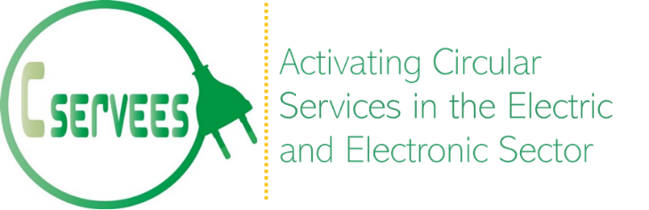

How can ICT enable Circular Economy Business Models?

Webinar, 11 May 2022

C-SERVEES (Activating Circular Services in the Electric and Electronic Sector) is a project funded under the Horizon 2020 Programme (2018-2022) that aims to boost circular economy business models in the Electrical and Electronic Equipment sectors. The business models have been developed through wide consultation with stakeholders; demonstrations are currently testing their viability involving four target products: washing machines, printers and toner cartridges, televisions and monitoring equipment used in telecoms.
The project has been developing ICT tools for bidirectional, secure information exchange throughout the EEE value chain to support new business models. They use a zero-knowledge protocol; industry partners are testing them to validate their functionalities: life-cycle tracking of products, end-users' feedback, interactive user and repair manuals, warranty tracking, consumables management, as well as management protocols for preparing for re-use or recycling.

Acronym: | C-SERVEES
Project title: | Activating Circular Services in the Electric and Electronic Sector
Contract Nº: | 776714
Start date: | 1st May 2018
Duration: | 54 months

This project has received funding from the European Union's Horizon 2020 research and innovation programme under grant agreement Nº 776714

Agenda

Moderator: Constantin Herrmann, Sphera

10:30 | Introduction to C-SERVEES | Vicente Vert Belenguer, AIMPLAS
10:35 | Introduction to the Circular Economy Business Models in C-SERVEES | Mohamed Osmani, Loughborough University
10:45 | The C-SERVEES digital information exchange platform | Teresa Oberhauser, Circularise
10:50 | How will the Circularise web application enhance value chain transparency? | Teresa Oberhauser, Circularise
11:05 | How will the Soltel platform foster public information exchange? | Germán Sánchez, Soltel
11:20 | How will the RINA-C logistics tool improve circularity? | Sara Fozza, RINA-C
11:35 | Implementation of the C-SERVEES Circular Economy Business Models in the demonstrations | Ana Isabel Díaz, GAIKER
11:40 | Q&A
12:00 | Concluding remarks | Constantin Herrmann, Sphera

Please register here

