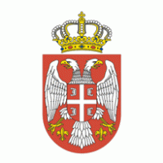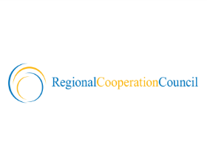

EUROPEAN COMMISSION SERBIA ITALIAN PRESIDENCY REGIONAL COUNCIL COOPERATION
RESEARCH
DIRECTORATE-GENERAL

DRAFT AGENDA

Meeting of the Steering Platform on Research for Western Balkan Countries in Trieste, Italy (Hotel Savoia Excelsior - 24 September 2014)

09:15 – 09:30  09:30 – 10:15 | Welcome address:  - - Italian Minister for Education, University Research, EU Presidency  - - CEI Secretary General  - - RCC  Opening Statements:  - Italian Presidency: presentation of Presidency Programme with focus on Research and Innovation;  - European Commission: representatives from EC/DG RTD and JRC  - Serbia on behalf of Western Balkan Region
10:15 – 11:30  11:30 – 12:00 | EU policy on Research and Innovation: latest developments  - Horizon 2020: Widening and Spreading Excellence programme (EC/DG RTD/tbc)  - Presentation of EU Strategy on International Cooperation including on association (EC/DG RTD)  - Innovation Union including European Research Area: state of implementation (EC/DG RTD)  - IPA II on Research and Innovation (EC/DG ELARG – H. Visser, tbc)  Q&A, contributions by participants  Family photo followed by Coffee break
12:00 – 13:15  13:30 – 14:30  14:30 – 16:00  16:00 – 16.30  19:30 | State of play on Research Infrastructures in Western Balkan Region:  - Mapping and preparing of national roadmap and participation in ESFRI by prof. G. Rossi, Vice-President of ESFRI  - Actions for Infrastructures in Horizon 2020; EC/DG RTD  (Ph. Froissard, tbc)  - JRC: outlining actions and cooperation for Enlargement countries and scientific support to regional strategies (Danube and Adriatic – Ionian regions)  Q&A, contributions by participants  Buffet Lunch together with Delegations to CEI Ministerial Meeting for Science and Technology  Regional Activities:  - State of play on 'South East European 2020 Strategy' – Pillar 'Smart Growth' (RCC)  - State of play on Implementation of Regional R&D Strategy for Innovation: launch of WISE (Croatia)  - Activities in the framework of Danube.Inco.Net  - Activities by UNESCO  - Activities by CEI: outline of CEI–PRAISE Programme aiming at strengthening the scientific communities of member countries, including integration of Research Infrastructures in Western Balkans through CEI S&T Network  Q&A, contributions by participants  Conclusions and next steps (Italian Presidency; CEI; Serbia; European Commission).  Q&A, contributions by participants  Social Event (tbc)  25 September 2014: possibility to visit scientific infrastructures and centres of excellence in Trieste

