Program: WBC-INCO.NET
Title of the suggested Action:

SCIENCE AND TECHNOLOGY PARK „TEHNOPOLIS“ OSIJEK
Subtitle (or short description in one sentence):
The STP TEHNOPOLIS Osijek is a part of regional triple helix system that support development of the knowledge and technology based enterprises, respecting highest business, ethical and environmental standards.

Description of the Action (approx. 1 page):
STP TEHNOPOLIS Osijek might be considered as a crucial component of the TRIPLE HELIX INNOVATION ECOSYSEM FOR DEVELOPMENT OF PANONIAN CROATIA that Josip Juraj Strossmayer University of Osijek build together with local governments in the region. Technology transfer and commercialization of publicly funded research are most important tools of that model. Besides the TEHNOPOLIS project, there are several ongoing complementary projects (TERA-TEHCRO Scientific Incubation Business Centre, EEN Croatia together with additional CIP projects) and several projects in preparatory phase (SIIF– UNITECH and CBC Croatia/Hungary - CHANCE). STP TEHNOPOLIS OSIJEK project is designed based on experience and it is custom made for its environment. To achieve effectiveness and financial efficiency, Josip Juraj Strossmayer University of Osijek develops integrated system for technology transfer where several EC and The World Bank initiatives are combined.
BASIC INFORMATION
Operation type: Alliance driven Science and Technology Park
Project size: construction lot # 10596-City of Osijek; lot size: 7,592 ha, 30.000 m² of office, laboratory and production space after three successive 2 year development phases
Project start: 1. January 2014
Project end: 31. December 2020.
Project ownership: JOSIP JURAJ STROSSMAYER UNIVERSITY OF OSIJEK - 100%
Estimated project value: 100 million €
Project management: TERA TEHNOPOLIS Ltd. (public, not for profit company owned by Josip Juraj Strossmayer University of Osijek, City of Osijek and Osijek-baranja county)
Current development of the project: master plan, feasibility study and conceptual design of the phase 1 (buildings T1 and T2) – already done

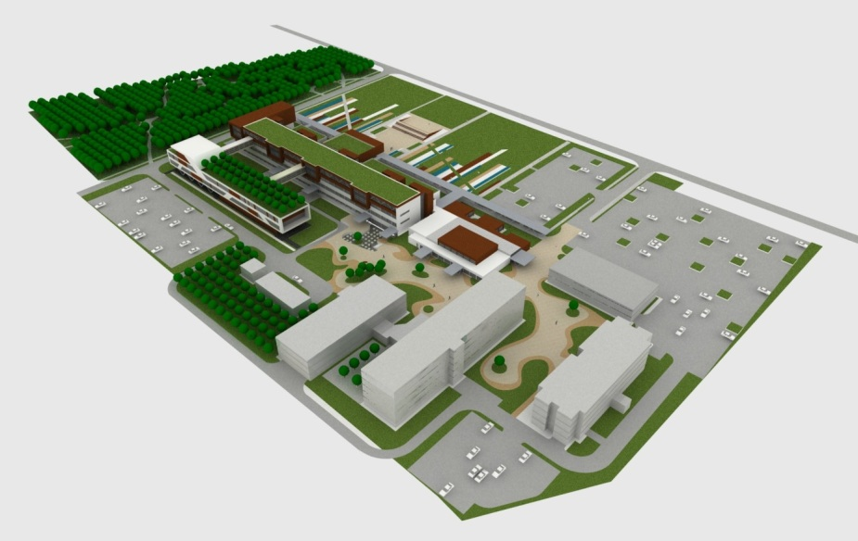
Picture 1. STP TEHNOPOLIS OSIJEK after 3rd development phase
References to running activities, lessons learnt from other regions, etc. (one paragraph):
All participants are carriers of competence and long experience in the preparation and implementation of infrastructure projects, and TERA TEHNOPOLIS team is holder of the competencies required for successful operation of science parks. TERA gained experience through many years of work, the establishment and development of business incubators that is continuously filled with more than 90% and now has 22 tenants with more than 80 employees. Besides that, TERA has experience in the preparation and implementation of EU projects, and as a member of the European Enterprise Network - EEN (funded through the CIP program), provides the infrastructure for the commercialization of innovative products and services on the EU market. In addition, TERA is the national carrier of the international project GREEN whose aim is to improve the business environment for SMEs (also funded through the CIP). TERA TEHNOPOLIS is fully equipped for protection and management of intellectual property and commercialization of research results through licensing and application in the economy and the spin-off project of the University.
Actors to be involved in the implementation and their roles (max. half a page):
Josip Juraj Strossmayer University of Osijek is the major higher education institution in the Eastern Croatia with the annual budget of more than 80 million €. The University of Osijek comprises 11 faculties, 5 Departments and the Academy of Arts, with more than 21.000 students and almost 1000 teaching and research staff. University strategic plan is to develop triple helix innovation ecosystem to increase value added of the university to the society. Focusing on technology transfer, University strives to become three stream funding University, and establish himself as the centre of an effective know-how hub, which is a dynamic scientific environment that incorporates all kinds of research, education and know-how commercialization in which the university collaborates with established technology-based firms as well as start-ups.
Important actors for the project are: companies and crafts that have completed incubation in the incubators TERA and BIOS, and their business has not yet developed to the stage where they can independently operate in a commercial zone; Centre for Excellence in the Food Production (to be established);8 counties of the Pannonian region; Polytechnics in Karlovac, Virovitica, SlavonskiBrod, Vukovar, Faculty of Metallurgy in Sisakand TeraTehnopolisLtd.. International partnerships relevant for the project includeinstitutions in EEN consortiums in Hungary, Serbia and Bosnia and Herzegovina and and numerous research partnership in created in TEMPUS and CBC programs, including University of Tuzla and Mihajlo Pupin Institute.

Expected impact (one paragraph):
Project introduce several important elements in the in the process of technology transfer: efficient use of equipment and other resources through open lab concept; networking of different competences and concentration of support for entrepreneurs in the region. In that way project foster transformation or regional HEI and PRO to three stream funding institutions. Areas of special interest for the development of the project are: biotechnology, environmental protection, information and communications technology, advanced manufacturing including robotics and nanotechnology, and the projects aimed at developing the regional economy (300 new business and re-organized companies with 1,500 employees). Operationalization of the project supports the three priorities of the Strategy for Europe 2020, because it affects the "smart, sustainable and inclusive development".

Relevance to the WBC region (one paragraph):
Relevance of the activities that Josip Juraj Strossmayer University of Osijek is undertaking in the field of entrepreneurship, technology transfer development of knowledge and technology based economy is significant to the region. Osijek is home of several important brands like CfE – Centre for Entrepreneurship, ICES – International Centre for entrepreneurial studies, TERA – Technology Development Centre, Be the Role model/BUDI UZOR® - international invention show and student business plan competition, BIOS incubator and NOA – savings and loan cooperative. All those institutions were pioneers in the process of transforming and developing local economy. Significant experience, competences and trained staff were acquired. STP TEHNOPOLIS is new brand that foster regional economic development through networking of existing competences. Besides existing, new partnerships are created and in that way project grows from national to the regional level.

Author:

Prof.dr.sc. Ivan Štefanić, TERA TEHNOPOLIS Ltd.,
Osijek, TrgLj. Gaja 6, Tel:+385-31-251-000, e-mail: stefanic@tera.hr

