“Action Plan to increase innovation capacities in the WBC”

Title of the suggested Action: “Enhancement of regional cooperation through Appointed Researchers Facilitators and WBC-Info Office E-services”
Subtitle (or short description in one sentence): Building capacities/institutions for inter-regional coordination and technical assistance in EU Programs applications in national and international level, through Appointed Researcher Facilitators (Stakeholders) in Balkan countries, to achieve:
- Regional institution building to promote coherence
- Identifying regional Centers of Excellence, avoiding fragmentation and duplication, regional research infrastructures
Description of the Action (approx. 1 page):
The Action aims to facilitate WBC.INCO-NET Project services in promoting research, technology, development and innovation for the benefit of Researchers in Balkan Region. The aim can be achieved by activating the stakeholders who are in contact and contributing for WBC Project. To optimize Regional E-services it is necessary to build, or nominate Regional Information (or Consulting) Office under the management of WBC Project for the coordination of the activities and to support researchers in common initiatives within an intelligent network services in Balkan Region.
The request to improve research infrastructure in Balkan Region is up to date with new developments of RTD in European countries and behind. The link between Balkan and European countries is a need for every researcher but it is more successful when supported in institutional level. WBC Project and the appointed researcher facilitators will operate in close cooperation for information transfer from Europe to the Region and vice versa.
New capacities building is already an initiative confirmed from WBC.INCO-Net Project supporting the Balkan researchers training workshops. Further on, the capacities within region should act as small “units” for operational plans in research advancement under the umbrella (management) of WBC Project. The idea is that WBC Project activates and organizes the specific group of researchers in the shape of an operational office or center for technical assistance in WBC project implementation, and more, the offices or centers themselves cooperate and coordinate the actions for more active participation in joint initiatives and research.
It is the time to continue to keep alive and benefit from the research capacities with background from WBC project training workshops. This Contingent of Experts can be the target groups for working at Regional office with main task to provide information and assistance to the interested stakeholders and their organizations. It will establish the database of the researcher profile and expertise and companies in their country. Once the office is nominate it will be in close cooperation with Contact Person of each country and with WBC Project manager running the Program for inter coordination of the New Action Plan in a confirmed network under the managing scheme proposed as below:
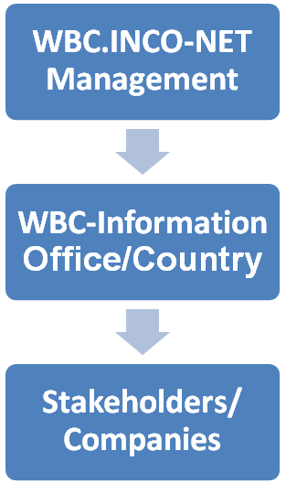
References to running activities, lessons learnt from other regions, etc. (one paragraph):
The institutionalization of such a network is approximately the same, with other institutional infrastructure (except that of science) that has created the European Union in every Balkan country, but with a difference that here it is proposed at the regional level to assist researchers contributions in building a common research and innovation platform.
In Tirana:
- The European Commission is providing the assistance through the Delegation of European Commission Office.
- The European Parliament is providing the services through the European Programs Information Office.
- Italian Cooperation Office.
- Others to be mention.
Actors to be involved in the implementation and their roles (max. half a page):
Firstly, all the stakeholders and experts being participants in the Training Workshops of WBC.INCO-NET project, secondly, other stakeholders confirmed from the National Contact Points and according to the WBC project management needs.
The role of the stakeholders is to support WBC project in the services for the companies they working for in their country, to network with other offices in the Region and be the messenger of WBC Project Actions working under the umbrella of WBC project management.
Expected impact (one paragraph):
The operational WBC-Info Offices should increase the efficiency of WBC project development covering all Balkan Region; identification the needs of researchers from the Balkan countries, enlargement the number of experts and companies which receive services through coordinated working plan; Facilitating and enhancement of European Info Zone dissemination.
Relevance to the WBC region (one paragraph):
Balkan region perspective is to become part of big European family. It is the most targeted aspiration for each Balkan countries people and government. As much as we know the standards and rules of the European countries as closed we are with the criteria set for the status of being candidate country for EU membership.
Author: name, affiliation, contact details (but you may also submit contributions anonymous)
Vera Shiko, MEng in Transport
Institute of Transport
Rr. E KAVAJES
Nd. 39 H.3 Ap.3
Njesia Bashkiake Nr. 10, Kodi Postar 1001
TIRANE
Albania
Tel/Fax: 00355 42 250057
Tel: 00355 42 232974
Mobile: 00355 692624713
www.ital.gov.al

