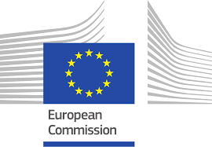

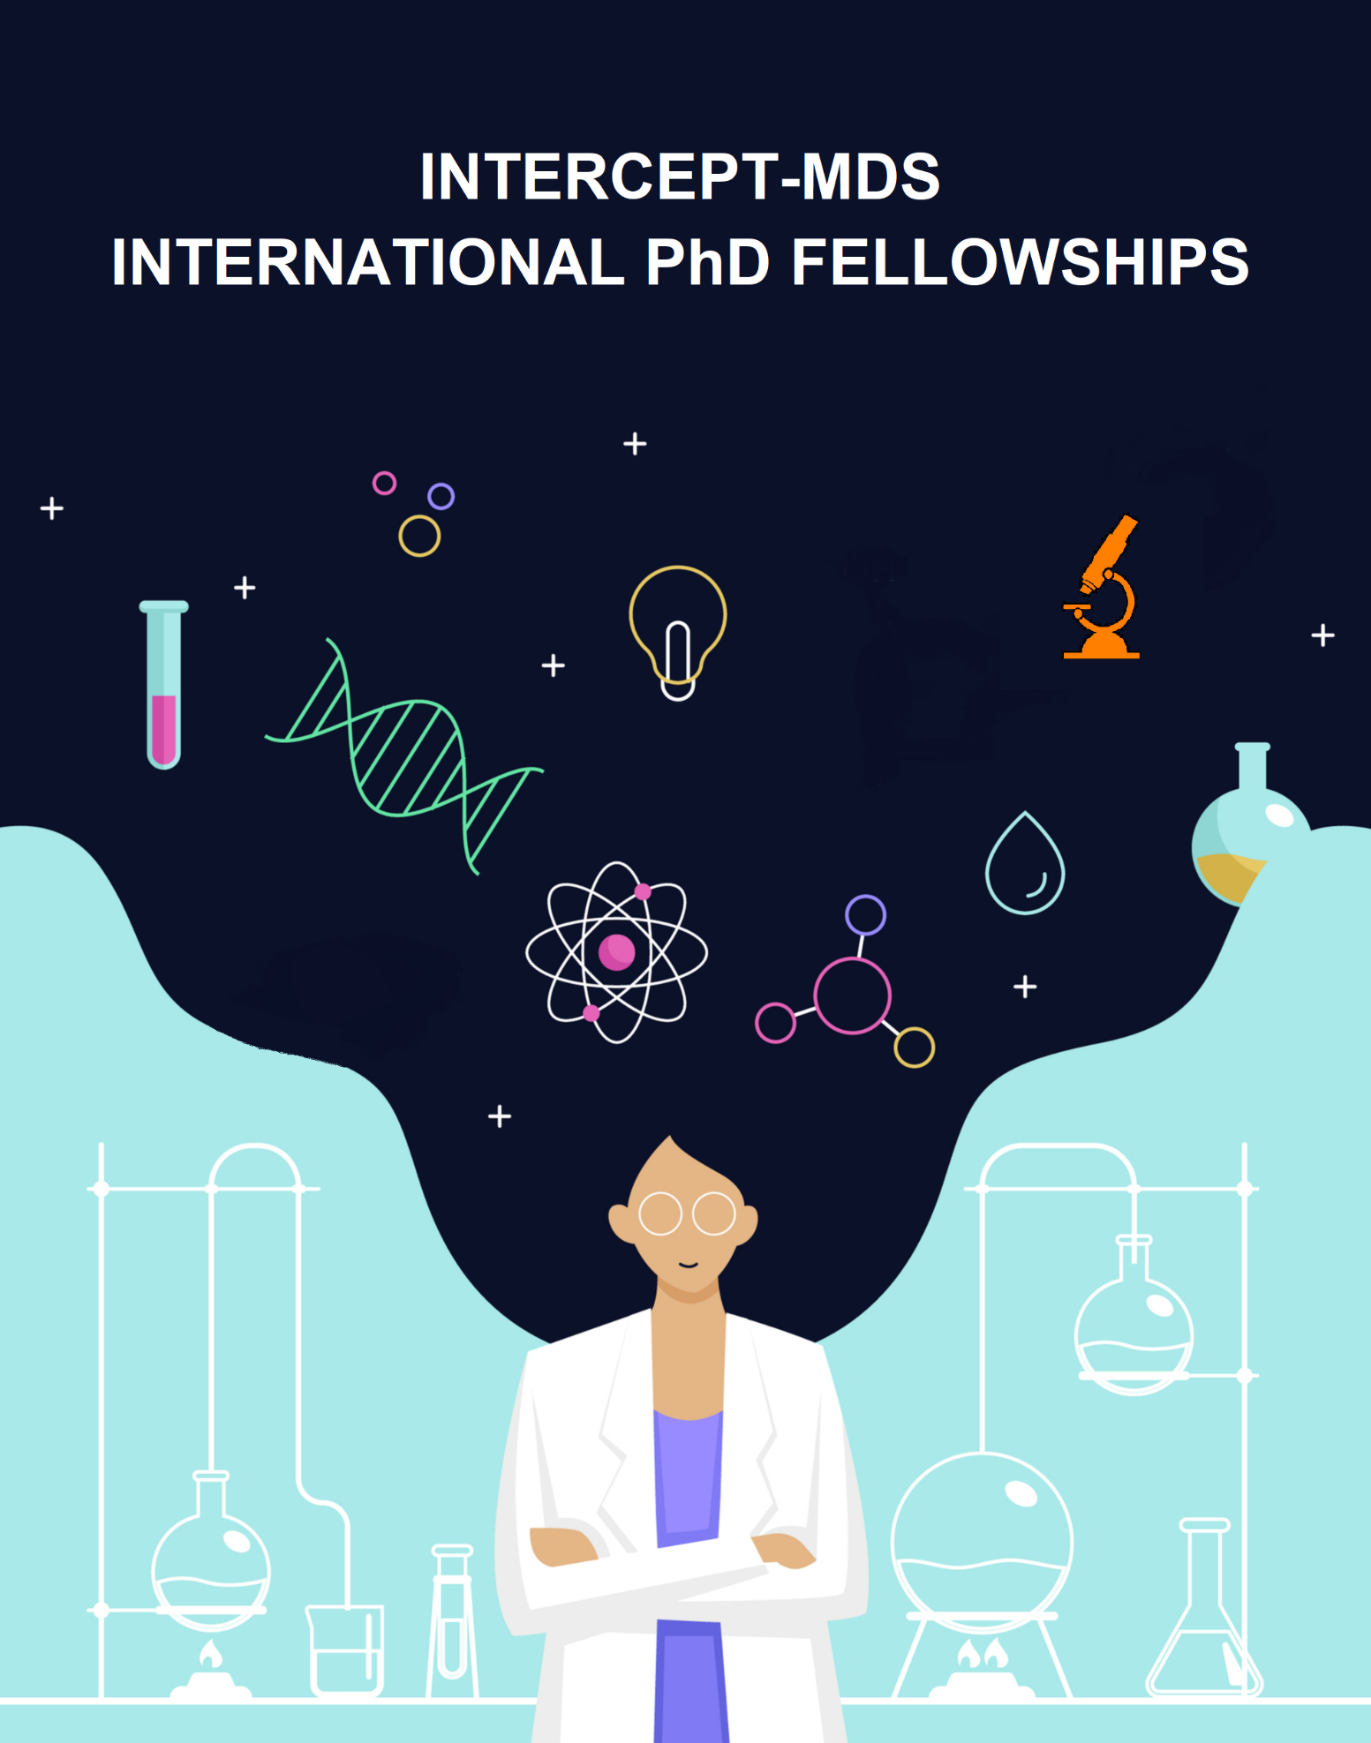

12 full-time PhD positions
HOST INSTITUTIONS:
- Josep Carreras Leukaemia Research Institute. Spain > Badalona
- Erasmus Medical Center. The Netherlands > Rotterdam
- Klinikum rechts der Isar der TU München. Germany > Munich
- Institut national de la sante et de la recherche medicale. France > Paris
- Veterinärmedizinische Universität Wien. Austria > Vienna
- Università degli Studi di Firenze. Italy > Florence
- Institute for Tumor Biology and Experimental Therapy, Georg-Speyer-Haus. Germany > Frankfurt
- MLL Munich Leukemia Laboratory. Germany > Munich
- University of Bergen. Norway > Bergen
- BioBam Bioinformatics. Spain > Valencia
RESEARCH PROFILE: First Stage Researcher (R1)
APPLICATION DEADLINE: 23 February 2021
EU RESEARCH FRAMEWORK PROGRAME: HORIZON 2020
MARIE SKOLODOWSKA CURIE GRANT AGREEMENT NUMBER: 953407

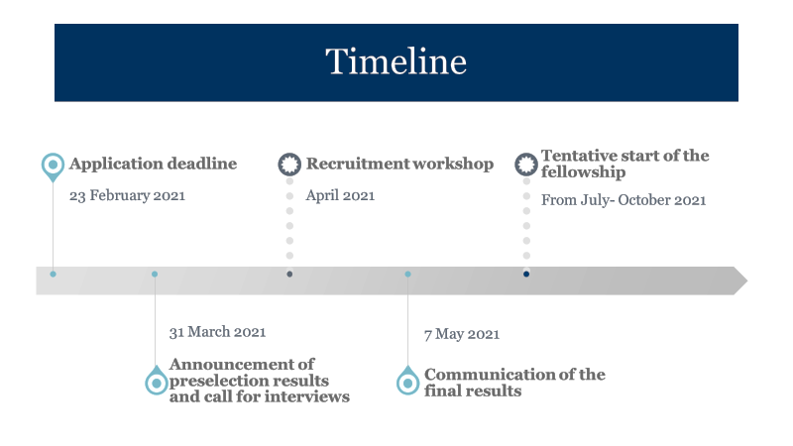

About the INTERCEPT-MDS network
The INTERCEPT-MDS network will train Europe’s first experts in the novel field of disease interception. Through an international call and open recruitment procedure, we will recruit 12 PhD candidates to carry out specific projects under the supervision of a Principal Investigator within one of the 10 world-leading European host institutions from the network.
Our future fellows will be enrolled in a PhD programme and will receive an outstanding and tailored training designed specifically for them. In addition to the training offered by the university, supervisors and host institutions, the PhD candidates will also carry out secondments in other European institutions within the network to provide the needed interactions to achieve research and training excellence, and improve the future career perspectives of our PhD fellows. The embedding within the INTERCEPT-MDS network’s experts and experienced trainers from two sectors (academia and industry) and two research environments (clinical and basic) offers a unique multidisciplinary and multisectoral training opportunity in the emerging field of disease interception within the health sciences.

Scientific project
Disease interception is a novel concept referring to the treatment of a disease before it fully develops by removing altered cells. To make disease cell interception a reality, researchers need to overcome two key challenges: First, to identify a few altered disease cells among many healthy ones. Second, the development of strategies that allow the specific targeting of malignant cells without affecting healthy cells. INTERCEPT-MDS will approach these challenges using myeloid diseases as a suitable paradigm for clonally evolving diseases and several innovative research tools, aiming at improving the diagnostics and treatment of haematological malignancies and other cancers. The highly complementary composition of the INTERCEPT-MDS network will provide all the key expertise and infrastructure to support the scientific excellence of our PhD candidates, and the transfer of knowledge is guaranteed through shared training.

PhD Positions
PhD Project 1: Impact of clonal haematopoiesis with indeterminate potential (CHIP) mutations on transcription in single-cells.
The PhD candidate will elucidate how early mutations in CHIP provide a growth advantage and contribute to the emergence of myelodysplastic syndromes. We will take a primarily computational approach but also perform own single-cell sequencing experiments. The ideal candidate will have previous knowledge in R and/or other scripting languages (such as Python), experience in working with Linux environment, bash scripting and knowledge of the main molecular biology techniques.
Host: Josep Carreras Leukaemia Research Institute, Spain.
Supervisors: Marcus Buschbeck and Roberto Malinverni (https://www.carrerasresearch.org/en/Chromatin_Metabolism_and_Cell_Fate).
Envisioned secondments: Erasmus Medical Centre and/or Universitätsklinikum Aachen AöR (The Netherlands and/or Germany, 3 months), MLL Munich Leukemia Laboratory (Germany, 1 month).

PhD Project 2: Dissect haematopoietic stem cell/progenitor-bone marrow niche (HSCP-BM) interaction on a single cell level in low risk myelodysplastic syndromes (MDS).
The PhD candidate will study the open question in MDS of how HSPCs can gain a clonal advantage in the bone marrow.
Host: Erasmus Medical Center, The Netherlands.
Supervisor: Rebekka K. Schneider (https://www.oncode.nl/person/rebekka.schneider).
Envisioned secondments: University of Bergen (Norway, 2 months), BioBam Bioinformatics (Spain, 2 months).

PhD Project 3: Cross-talk between single haematopoietic stem cell/progenitors (HSCP) and bone marrow (BM) niche in myelodysplastic syndromes (MDS) and secondary-type acute myeloid leukaemia (sAML).
The PhD candidate will study how aging and disease influences communication between stem and stroma cells. The candidate will be able to distinguish intrinsic and extrinsic alterations and identify pathways and factors that can be further evaluated for as drug targets.
Host: Klinikum rechts der Isar der TU München, Germany.
Supervisor: Katharina Götze (https://med3.mri.tum.de/de/person/prof-dr-katharina-g%C3%B6tze).
Envisioned secondments: GenomeScan B.V. (The Netherlands, 3 months), Institute for Tumor Biology and Experimental Therapy, Georg-Speyer-Haus (Germany, 3 months).

PhD Project 4: Phenotypic heterogeneity of myelodysplastic cells and influence of epigenetic therapies.
The PhD candidate will report, for the first time at the single cell level, the evolution of the transcriptome of leukaemic and nonleukaemic cells upon treatment with hypomethylating agents and IDH inhibitors. This will allow them to compare for the first time the channelling of genetic and phenotypic heterogeneity driven by different epigenetic therapies.
Host: Institut national de la sante et de la recherche medicale (INSERM), France.
Supervisors: Alex Puissant and Raphael Itzykson (https://gencelldis.fr/a-puissant-team/)
Envisioned secondments: GenomeScan B.V. (The Netherlands, 2 months), University of Bergen (Norway, 2 months).

PhD Project 5: Understanding and reverting the epigenetic reprogramming of bone marrow (BM) stroma cells in myelodysplastic syndromes.
The PhD candidate will study the support capacity of bone marrow stroma cells towards healthy and disease haematopoietic stem cell/progenitors (HSPCs). The fellow will identify candidate chromatin regulators and pinpoint ways for therapeutic intervention. The ideal candidate should have a strong background in immunology and solid wet-lab skills.
Host: Josep Carreras Leukaemia Research Institute, Spain.
Supervisors: Marcus Buschbeck and René Winkler (https://www.carrerasresearch.org/en/Chromatin_Metabolism_and_Cell_Fate).
Envisioned secondments: Klinikum rechts der Isar der TU München and Institute for Tumor Biology and Experimental Therapy, Georg-Speyer-Haus (Germany, 3 months). Depending on the project development: Aelian Bio (Austria, 1 month).

PhD Project 6: Targeted inhibition of the NUP98-NSD1 fusion oncogene in myelodysplastic syndromes (MDS) and acute myeloid leukaemia (AML) models by NSD1 inhibitors.
The PhD candidate will analyse the efficiency of epigenetic drugs as a mechanism to decrease aberrant histone methylation activity in MDS and sAML driven by the fusion protein of NUP98 and the histone methylase NSD1.
Host: Josep Carreras Leukaemia Research Institute, Spain.
Supervisors: Maria Berdasco and Manel Esteller (https://www.carrerasresearch.org/en/epigenetic-therapies_132564 and https://www.carrerasresearch.org/en/cancer-epigenetics_124284).
Envisioned secondments: Veterinärmedizinische Universität Wien (Austria, 4 months). Depending on the project development: Aelian Bio (Austria, 1 month).

PhD Project 7: Functional identification of effectors of fusion proteins that drive secondary-type acute myeloid leukaemia (sAML).
The PhD candidate will identify critical factors that control the initiation and maintenance of fusion protein-driven MDS/AML. Detailed studies will address the mechanistic basis of high-confidence candidates.
Host: Veterinärmedizinische Universität Wien, Austria.
Supervisor: Florian Grebien (https://grebienlab.com).
Envisioned secondments: Institut national de la sante et de la recherche medicale (France, 4 months), GenomeScan B.V. (The Netherlands, 2 months).

PhD Project 8: DNA methylation as determinant of myelodysplastic syndromes (MDS) treatment with hypomethylating agents.
The PhD candidate will study determinants of hypomethylating agent response that could be further exploited for the development of combinatorial drug targets. In addition, the candidate will identify and exploit differentially methylated regions for the development of a predictive biomarker for response and further assess if single-cell resolution would increase diagnostic power.
Host: Università degli Studi di Firenze, Italy.
Supervisor: Valeria Santini (https://www.kcl.ac.uk/lsm/research/divisions/cancer/research/groups/haematooncology/research/bonemarrow/mdsconsortium/aboutus/university-florence).
Envisioned secondments: Josep Carreras Leukaemia Research Institute (Spain, 3 months), MLL Munich Leukemia Laboratory (Germany, 2 months).

PhD Project 9: Exploiting 3D organotypic niche models to dissect the cellular crosstalk between niche and haematopoietic stem cell/progenitors (HSPCs) in myelodysplastic syndromes (MDS).
The PhD candidate will use fully humanized 3D organotypic bone marrow niche models as a complementary approach to patient-derived xenograft (PDX) models to explore niche dependencies in MDS and perform screens that aim to identify druggable modules that promote the fitness and progressive clonal dominance of malignant clones.
Host: Institute for Tumor Biology and Experimental Therapy, Georg-Speyer-Haus, Germany.
Supervisor: Hind Medyouf (https://georg-speyer-haus.de/staff/medyouf-forschung/).
Envisioned secondments: GenomeScan B.V. (The Netherlands, 3 months), University of Bergen (Norway, 2 months).

PhD Project 10: Enhancing the informative value of bulk bone marrow (BM) RNA-seq by inferring cell-type contributions.
The PhD candidate will develop an artificial intelligence-based method that will allow the inference of the contributions of different cell types to bulk RNA-seq data from complex mixtures. The ideal candidate will have previous knowledge in R and/or other scripting languages (such as Python), experience in working with Linux environment, bash scripting and knowledge of the main molecular biology techniques.
Host: MLL Munich Leukemia Laboratory, Germany.
Supervisor: Torsten Haferlach (https://www.mll.com/en/about-us/team.html).
Envisioned secondments: Josep Carreras Leukaemia Research Institute (Spain, 3 months), BioBam Bioinformatics (Spain, 1 month).

PhD Project 11: Development of pre-clinical patient-derived xenograft (PDX) models of myelodysplastic syndromes (MDS).
The PhD candidate will develop new humanized mouse PDX models and assess their ability to maintain the disease phenotype and cellular complexity. The best PDX models will enable the pre-clinical testing of new innovative drugs. Monitoring treatments at the single cell level will allow the determination of treatment efficacy and possible occurrence of resistance.
Host: University of Bergen, Norway.
Supervisor: Emmet McCormack (https://www.uib.no/en/ccbio/107680/emmet-mccormack).
Envisioned secondments: Klinikum rechts der Isar der TU München (Germany, 4 months), GenomeScan B.V. (The Netherlands, 1 month).

PhD Project 12: Development of methods for the functional analysis of single cell RNA-seq data.
The PhD candidate will develop a new analysis framework that will make possible a better understanding of the underlying biology of cell subpopulations in heterogenic tissues and comparison across experimental conditions. The ideal candidate would have a background in bioinformatics, programming, and functional genomics.
Host: BioBam Bioinformatics, Spain.
Supervisor: Stefan Götz (https://www.biobam.com/about/?cn-reloaded=1).
Envisioned secondments: Università degli Studi di Firenze (Italy, 2 months), Josep Carreras Leukaemia Research Institute (Spain, 2 months).

REQUIREMENTS:
Eligibility criteria:
We welcome applications from PhD candidates from any country fulfilling the following criteria:
- Eligible candidates must not have resided or carried out their main activity (work, studies, etc.) in the country of their host institution for more than 12 months in the 3 years immediately prior to their recruitment by the host institution (i.e. the starting date indicated in the employment contract/equivalent direct contract).
- Eligible candidates shall at the date of recruitment by the host institution (i.e. the starting date indicated in the employment contract/equivalent direct contract), be in the first 4 years (full-time equivalent research experience) of their research careers and not have been awarded a doctoral degree.
- Eligible candidates must have a master’s degree relevant for the chosen position (including biology, medicine, biochemistry, bioinformatics or a related discipline, depending on each PhD project) or its equivalent that would entitle them to a doctorate by July 2021, or must hold an official university qualification from a country of the European Higher Education Area with a minimum of 300 ECTs of official university studies.

Successful candidates must have a high level of proficiency in written and spoken English, which will be assessed with the motivation letter and the interview, respectively.

ADDITIONAL INFORMATION:
Application and selection process
The application will be done through an online application platform to be found on the INTERCEPT-MDS website: www.intercept-mds.eu. Applications must be in English. Each applicant may apply to a maximum of three individual research projects.
Eligible applications will be ranked on the basis of CVs and merits by a selection committee. The 3 best candidates for each position will be invited to a recruitment workshop in April 2021 (date to be confirmed) where the final candidates will be selected.
Applicants with a positive evaluation but not selected will be included on a reserve list to cover eventual future positions and might be contacted at a later stage.

Timeline
- Application deadline: 23 February 2021
- Announcement of preselection results and call for interviews: 31 March 2021
- Recruitment workshop: Short-listed candidates will be interviewed at the end of April 2021 (date to be confirmed). Owing to the current situation caused by the COVID-19 pandemic, we anticipate the possibility of conducting interviews in a virtual format. Full details regarding the interview process will be sent to invited candidates during the arrangement of interviews.
- Communication of the final results: 7 May 2021
- Tentative start of the fellowship: Between July and October 2021

Benefits
- 3-year full-time employment contract (salary depends on the country of the recruitment considering both the local and MSCA regulations for Early Stage Researchers and their family status at the time of the recruitment).
- Enrolment in a PhD programme.
- Shared research and innovative multidisciplinary and multisectoral training by experts and experienced trainers from two sectors (academia and industry) and two research environments (clinic and basic).
- A structured training programme consisting of soft skill courses, targeted workshops, retreats, social events and networking.
- Secondments at other institutions within the INTERCEPT-MDS consortium.
- Gaining experience abroad.
- Opportunities for participation in national and international meetings.
- Enlarged professional network and improved future scientific career perspective in academia and the private sector.

For further information on the INTERCEPT-MDS ITN and the application process, please visit www.intercept-mds.eu.

This project has received funding from the European Union’s Horizon 2020 research and innovation programme under the Marie Skłodowska-Curie grant agreement No 953407.

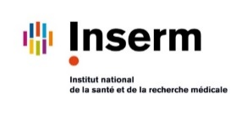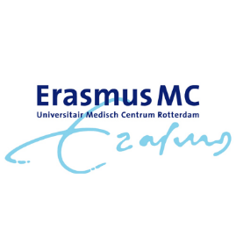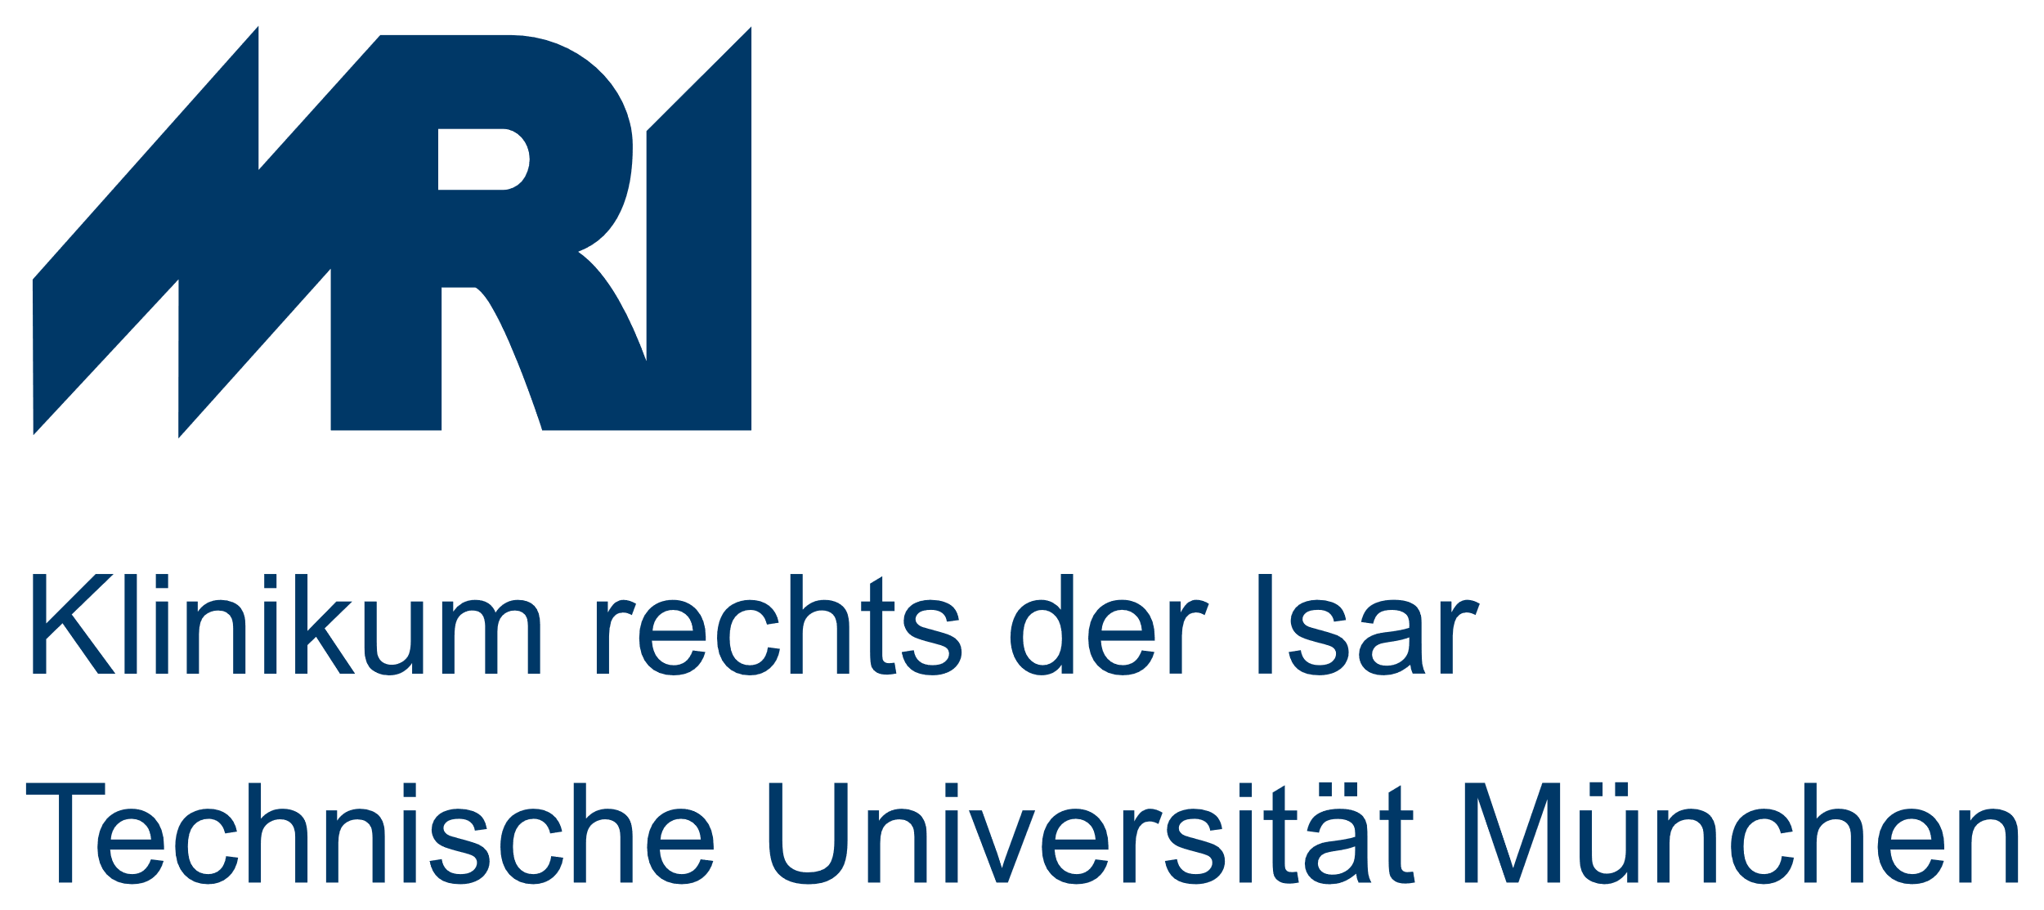

First Stage Researcher (R1) PhD candidate or equivalent. Early stage researcher with less than 4 years FTE research experience.

